Multiple-Choice Test

Chapter 05.02

Direct Method of Interpolation

- A unique polynomial of degree ________________ passes through 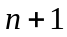 data points.
- or less
- or less

- The following data of the velocity of a body is given as a function of time.
Time (s) | 0 | 15 | 18 | 22 | 24
Velocity (m/s) | 22 | 24 | 37 | 25 | 123
The velocity in m/s at 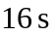 using linear polynomial interpolation is most nearly
- 27.867
- 28.333
- 30.429
- 43.000

- The following data of the velocity of a body is given as a function of time.
Time (s) | 0 | 15 | 18 | 22 | 24
Velocity (m/s) | 22 | 24 | 37 | 25 | 123
The velocity in m/s at using quadratic polynomial interpolation is most nearly
- 27.867
- 28.333
- 30.429
- 43.000

- The following data of the velocity of a body is given as a function of time.
Time (s) | 0 | 15 | 18 | 22 | 24
Velocity (m/s) | 22 | 24 | 37 | 25 | 123
Using quadratic interpolation, the interpolant
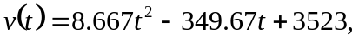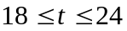
approximates the velocity of the body. From this information, the time in seconds at which the velocity of the body is 35 m/s during the above time interval of 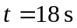 to 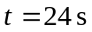 is
- 18.667
- 20.850
- 22.200
- 22.294

- The following data of the velocity of a body is given as a function of time.
Time (s) | 0 | 15 | 18 | 22 | 24
Velocity (m/s) | 22 | 24 | 37 | 25 | 123
One of the interpolant approximations for the velocity from the above data is given as
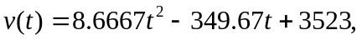
Using the above interpolant, the distance in meters covered by the body between 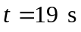 and 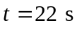 is most nearly
- 10.337
- 88.500
- 93.000
- 168.00

- The following data of the velocity of a body is given as a function of time.
Time (s) | 0 | 15 | 18 | 22 | 24
Velocity (m/s) | 22 | 24 | 37 | 25 | 123
If you were going to use quadratic interpolation to find the value of the velocity at 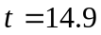 seconds, what three data points of time would you choose for interpolation?
- 0, 15, 18
- 15, 18, 22
- 0, 15, 22
- 0, 18, 24

For a complete solution, refer to the links at the end of the book.

